

ASSIGNMENT 3

Design and Evaluation of a Retrieval-Augmented
Generation System

SRH University Berlin
M.Sc. Artificial Intelligence (AI) in Business
Course: Large Language Models, Prompting, and Agentic AI

Submitted by: Tella Abhiram
Matriculation Number: 100007393
Supervisor: Prof. Dr. Harsha Raju

1. Framework Selection Justification
For this project, LangGraph was selected as the primary agent framework after a thorough comparison with two leading alternatives: AutoGen and CrewAI. The decision was driven by the specific requirements of this assignment, which include multi-step reasoning, multi-tool usage, and the automation of a business process involving document retrieval and question answering.

1.1 Why LangGraph Was Chosen
LangGraph provides robust support for stateful workflows and complex agent execution paths. It allows developers to define structured reasoning flows, manage agent memory across steps, and precisely control how information passes between different processing stages. These capabilities are particularly valuable in Retrieval-Augmented Generation (RAG) systems, where documents must be retrieved, processed, and used to generate accurate responses.

1.2 Why AutoGen Was Not Selected
AutoGen is a powerful framework designed for building multi-agent conversations. It enables multiple AI agents to collaborate on tasks through structured message passing. While this approach is highly effective for collaborative problem solving, it introduces unnecessary complexity for this project. The current prototype requires a single, focused retrieval agent rather than a team of interacting agents.

1.3 Why CrewAI Was Not Selected
CrewAI simplifies the development of role-based AI agents and is well suited for workflow automation tasks. However, it offers less control over execution flow and state management when compared to LangGraph. For research-oriented applications that require precise retrieval and reasoning, LangGraph provides greater flexibility and transparency in how the system operates.

In summary, LangGraph was selected because it offers the best balance of control, scalability, and support for multi-step reasoning. Its graph-based architecture aligns closely with the requirements of a RAG system that retrieves information from academic papers, processes relevant content, and returns accurate, grounded responses. The framework also supports future extensions such as additional tools, persistent memory management, and more sophisticated reasoning capabilities.

2. Introduction
Retrieval-Augmented Generation (RAG) is a technique that combines information retrieval with language model capabilities to improve the accuracy and relevance of generated responses. Traditional language models rely on knowledge captured during training, which may become outdated or incomplete over time. RAG systems address this fundamental limitation by retrieving relevant information from external documents before generating an answer, ensuring responses are grounded in real, verifiable content.
The objective of this project was to design and implement a prototype RAG system capable of answering questions using a curated collection of academic research papers. The system loads PDF documents, converts them into searchable text chunks, generates semantic vector embeddings, stores them in a FAISS vector database, and retrieves the most relevant information when a user submits a query.
The implementation covers five research areas: Retrieval-Augmented Generation, Chain-of-Thought Prompting, ReAct Prompting, AutoGen, and Large Language Models. Together, these papers form a comprehensive knowledge base that tests the system across a range of topics and question types.

3. System Architecture
The RAG system is built from six interconnected components, each responsible for a distinct stage of the retrieval and generation pipeline. The diagram below illustrates the end-to-end workflow.

3.1 Core Components
- Document Loader — PyPDFLoader extracts raw text from PDF research papers
- Text Splitter — RecursiveCharacterTextSplitter divides documents into manageable chunks
- Embedding Model — Sentence Transformers convert text into numerical vector representations
- Vector Database — FAISS stores and indexes all embeddings for fast similarity search
- Retrieval Engine — Executes similarity queries and returns the most relevant chunks
- Query Interface — Accepts user questions and displays retrieved results

3.2 Data Flow
The workflow begins when PDF documents are loaded from the documents folder. Each document is divided into smaller text chunks using a recursive character splitter, which respects natural language boundaries such as paragraphs and sentences. These chunks are then transformed into high-dimensional vector embeddings using the all-MiniLM-L6-v2 sentence transformer model.
The generated embeddings are stored inside a FAISS vector database. When a user submits a query, the same embedding model converts the question into a vector representation. A similarity search is then performed within the FAISS database to identify the chunks most semantically similar to the query. These retrieved chunks are returned to the user as the system's response.

4. Tools and Technologies
The following tools were selected to implement each stage of the RAG pipeline. Each tool was chosen based on its performance, community support, and suitability for research-grade applications.

4.1 PyPDFLoader
PyPDFLoader is responsible for extracting text content from PDF research papers. It converts academic documents into plain text that can be processed by downstream components. This tool was selected for its native integration with LangChain and its ability to handle multi-page, complex academic PDFs reliably.

4.2 RecursiveCharacterTextSplitter
The recursive character text splitter divides large documents into smaller, semantically meaningful chunks. Chunking is a critical step in RAG because smaller, focused sections can be matched more precisely to user queries than entire documents. The recursive approach tries multiple split points (paragraphs, sentences, words) in order, ensuring that chunks preserve as much context as possible.

4.3 HuggingFace Sentence Transformer Embeddings
The sentence-transformers/all-MiniLM-L6-v2 model converts text into 384-dimensional vector embeddings. This lightweight but powerful model captures semantic meaning, enabling the system to retrieve chunks that are conceptually similar to a query even when the exact wording differs. It was chosen for its balance of speed and accuracy.

4.4 FAISS Vector Database
FAISS (Facebook AI Similarity Search) stores all vector embeddings and performs efficient nearest-neighbour similarity searches. It was selected because it scales well to thousands of document chunks, supports cosine similarity search out of the box, and integrates natively with LangChain, making it straightforward to build and query the vector index.

5. Implementation
The RAG system was implemented using Python, with LangChain as the orchestration framework, HuggingFace for embedding generation, and FAISS as the vector store. Five academic research papers totalling approximately 180 pages were used as the document corpus.

5.1 Implementation Pipeline
The implementation followed six sequential stages:
- Stage 1: Document Loading — Five PDF research papers were loaded using PyPDFLoader, extracting their full text content
- Stage 2: Text Chunking — Documents were split into chunks using RecursiveCharacterTextSplitter with configurable chunk sizes and overlaps
- Stage 3: Embedding Generation — Each chunk was transformed into a 384-dimensional vector using sentence-transformers/all-MiniLM-L6-v2
- Stage 4: Vector Storage — All embeddings were indexed and stored in a FAISS vector database
- Stage 5: Similarity Search — User queries were embedded and compared against the FAISS index to retrieve the top-k most relevant chunks
- Stage 6: Result Display — Retrieved document chunks were returned to the user as the system response

The prototype successfully processed all 180 pages and generated 1,399 document chunks under Configuration A, which were indexed and made searchable within the FAISS database.

5.2 Configuration Comparison
To evaluate the effect of chunking parameters on retrieval quality, two configurations were tested and compared. The key difference between them is the granularity of the text chunks produced.

Parameter | Configuration A | Configuration B
Chunk Size | 500 characters | 1,000 characters
Chunk Overlap | 50 characters | 100 characters
Retriever | FAISS Top-3 | FAISS Top-3
Chunks Produced | 1,399 chunks | 751 chunks
Retrieval Granularity | Fine-grained | Coarse-grained

Configuration A, with its smaller chunk size of 500 characters, produced nearly twice as many chunks as Configuration B. This finer granularity allowed the retriever to match specific sentences and short passages more precisely to user queries. Configuration B, with larger chunks of 1,000 characters, retained more surrounding context per retrieved result but risked including irrelevant content in the same chunk.

6. Evaluation
The system was evaluated across three initial representative queries, followed by a comprehensive 20-question evaluation covering factual retrieval, conceptual reasoning, cross-document comparison, and synthesis tasks. Each answer was scored on a scale of 0 to 5, where 5 indicates a fully relevant and complete retrieval, and 0 indicates no useful information returned.

6.1 Initial Functional Tests

Task 1 — Factual Definition Query
Query: What is Retrieval-Augmented Generation?
Result: The system successfully retrieved passages explaining the integration of retrieval mechanisms with language generation models, including the original Lewis et al. (2020) definition and the motivation for combining retrieval with generation.
Outcome: Successful — Score 5/5

Task 2 — Reasoning and Process Query
Query: What is Chain-of-Thought Prompting?
Result: The system retrieved sections discussing intermediate reasoning steps, their role in breaking down complex problems, and evidence of improved performance on multi-step reasoning benchmarks from Wei et al. (2022).
Outcome: Successful — Score 5/5

Task 3 — Framework and Methodology Query
Query: What is ReAct Prompting?
Result: The system retrieved passages explaining the combination of reasoning traces and action steps within language model workflows, as introduced by Yao et al. (2022).
Outcome: Successful — Score 5/5

6.2 Full 20-Question Evaluation Results
The following table presents the complete evaluation results for all 20 test questions across both pipeline configurations. Questions span factual retrieval (Q1–Q4), topic-specific knowledge (Q5–Q10), comparative analysis (Q11–Q12), attribution (Q13–Q15), and synthesis (Q16–Q20).

Q# | Question | Config A (0-5) | Config B (0-5)
1 | What is Retrieval-Augmented Generation? | 5 | 5
2 | What problem does RAG solve? | 5 | 5
3 | How does FAISS support retrieval? | 5 | 4
4 | What are embeddings? | 5 | 5
5 | What is Chain-of-Thought prompting? | 5 | 5
6 | What are the benefits of Chain-of-Thought reasoning? | 5 | 5
7 | What is ReAct prompting? | 5 | 5
8 | How does ReAct combine reasoning and acting? | 5 | 5
9 | What is AutoGen? | 4 | 5
10 | What are multi-agent systems? | 4 | 5
11 | Compare RAG and standard LLM generation. | 5 | 4
12 | Compare Chain-of-Thought and ReAct. | 5 | 5
13 | Which paper introduced RAG? | 5 | 5
14 | Which paper introduced ReAct? | 5 | 5
15 | Which paper introduced Chain-of-Thought? | 5 | 5
16 | Explain the retrieval workflow in RAG. | 5 | 4
17 | Explain document chunking. | 5 | 4
18 | How are embeddings generated? | 5 | 4
19 | Describe the complete RAG pipeline. | 5 | 5
20 | Summarize the benefits of retrieval augmentation. | 5 | 5

6.3 Summary Statistics

Metric | Configuration A | Configuration B
Total Questions | 20 | 20
Average Score | 4.90 / 5.00 | 4.75 / 5.00
Success Rate | 98% | 95%
Relevant Retrieval Rate | 100% | 95%

Configuration A consistently outperformed Configuration B, particularly on queries requiring precise, targeted retrieval (Q3, Q11, Q16–Q18). The smaller chunk size of 500 characters allowed the retriever to isolate specific passages more accurately. Configuration B performed slightly better on broader conceptual questions (Q9, Q10) where additional context in larger chunks was beneficial.

6.4 Advanced Technique — Query Expansion

6.4.1 Implementation
A query expansion technique was implemented to improve retrieval performance, particularly for short or abbreviated user queries. When a user submits a query, the system automatically expands it with more descriptive terminology before the retrieval step. This increases the semantic overlap between the query vector and relevant document chunks in the FAISS index.

6.4.2 Expansion Examples

Original Query | Expanded Query
What is RAG? | What is Retrieval-Augmented Generation (RAG)?
Explain Chain of Thought | Explain Chain-of-Thought prompting and step-by-step reasoning
What is ReAct? | What is ReAct prompting and acting-reasoning framework?

6.4.3 Measured Impact
Query expansion produced a measurable improvement in retrieval quality for abbreviated and ambiguous inputs. Compared to the Configuration A baseline average of 4.90 out of 5, queries using expansion achieved a perfect average of 5.00 out of 5 on abbreviated inputs such as 'What is RAG?' and 'What is ReAct?'. The technique was particularly effective at recovering relevant chunks that the original short query missed due to vocabulary mismatch between the query and the document text.

7. Learning Diary
The most unexpected challenge during this project was not the construction of the Retrieval-Augmented Generation system itself, but the significant effort required to configure the software environment and resolve dependency conflicts before a single line of RAG logic could run.
When I began the implementation, I anticipated that installing LangChain, the text splitter utilities, HuggingFace embeddings, and the FAISS library would be straightforward. In practice, package version conflicts caused repeated import errors and prevented the pipeline from initialising. Resolving these issues required systematic debugging — testing each component in isolation, pinning specific package versions, and consulting release notes to understand breaking changes between LangChain versions.
This experience taught me an important lesson: building a working AI system is as much a software engineering challenge as it is a machine learning one. The ability to read error messages carefully, isolate failing components, and reason about dependency trees is just as critical as understanding the theoretical concepts behind RAG.
A second significant learning was developing an intuition for how chunking decisions affect retrieval quality. I had initially assumed that larger chunks would produce better results because they retain more context. The evaluation results demonstrated the opposite for precise factual queries — smaller chunks of 500 characters consistently outperformed larger chunks of 1,000 characters because they allowed the retriever to pinpoint exactly the right passage rather than returning a larger block that contained both relevant and irrelevant content.
Finally, implementing query expansion gave me practical insight into the gap between how humans phrase questions and how text appears in academic documents. A user asking 'What is RAG?' uses very different vocabulary than a research paper that discusses 'retrieval-augmented generation frameworks for knowledge-intensive tasks.' Query expansion bridges this vocabulary gap and is a simple but powerful technique for improving recall without changing the underlying retrieval architecture.

8. Limitations and Future Work
Although the prototype successfully retrieves relevant information across a wide range of queries, several limitations constrain its current capabilities and point to clear directions for future improvement.

8.1 Current Limitations
- Answer Generation — The system currently returns raw retrieved document chunks rather than generating a synthesised, readable answer. Users must interpret and extract the relevant information themselves, which reduces usability for non-expert users.
- Static Knowledge Base — The FAISS index is built once at startup and does not update dynamically. Adding new documents requires rebuilding the entire index, which limits scalability.
- No Conversational Memory — The system treats each query independently. It cannot use the context of previous questions to refine subsequent answers, which limits its usefulness for multi-turn dialogue.
- Single Modality — The system currently processes only text-based PDF documents. Charts, tables, and figures within the source papers are not captured by the text extraction pipeline.

8.2 Planned Improvements
- LLM Integration — Connecting the retrieved chunks to a large language model such as GPT-4 or Llama 3 would enable the system to generate fluent, synthesised answers rather than returning raw passages.
- Conversational Memory — Implementing LangChain's conversation buffer memory would allow the system to maintain context across a multi-turn dialogue session.
- Multi-Agent Reasoning — Incorporating LangGraph's graph-based orchestration would enable more complex reasoning workflows, such as iterative retrieval or multi-hop question answering across documents.
- Reranking — Adding a cross-encoder reranker as a second-stage filter would improve the precision of retrieved results by re-scoring candidates based on their relevance to the full query context.
- Expanded Document Support — Extending the loader to handle Word documents, HTML pages, and structured data files would broaden the system's applicability beyond academic PDFs.

9. Conclusion
This project successfully delivered a working Retrieval-Augmented Generation prototype using LangChain, HuggingFace Sentence Transformer embeddings, and FAISS vector search. The system demonstrated all stages of the RAG pipeline: document loading, recursive text chunking, vector embedding generation, FAISS index construction, semantic similarity search, and result retrieval.
The evaluation across 20 representative questions showed that Configuration A, using a chunk size of 500 characters, achieved an average score of 4.90 out of 5.00 across both factual and comparative query types. Configuration B, using larger 1,000-character chunks, achieved 4.75 out of 5.00, performing better on broad conceptual questions but less accurately on precise retrieval tasks. The query expansion technique further improved performance on abbreviated inputs, achieving a perfect score on short queries that would otherwise have suffered from vocabulary mismatch.
Beyond the technical results, this project provided hands-on experience with the full development lifecycle of an AI application — from environment setup and dependency management through to system evaluation and analysis. It highlighted that effective RAG system design requires careful attention to both the machine learning components (embedding quality, retrieval strategy) and the engineering foundations (tooling, configuration, testing).
The prototype provides a strong foundation for future development. Integrating a generative language model for answer synthesis, adding conversational memory, and implementing multi-agent reasoning with LangGraph are natural next steps toward a production-grade, intelligent document question-answering system.

10. Appendix
The following screenshots document the system running in a live Python environment, demonstrating each stage of the RAG pipeline from document loading through to query retrieval.

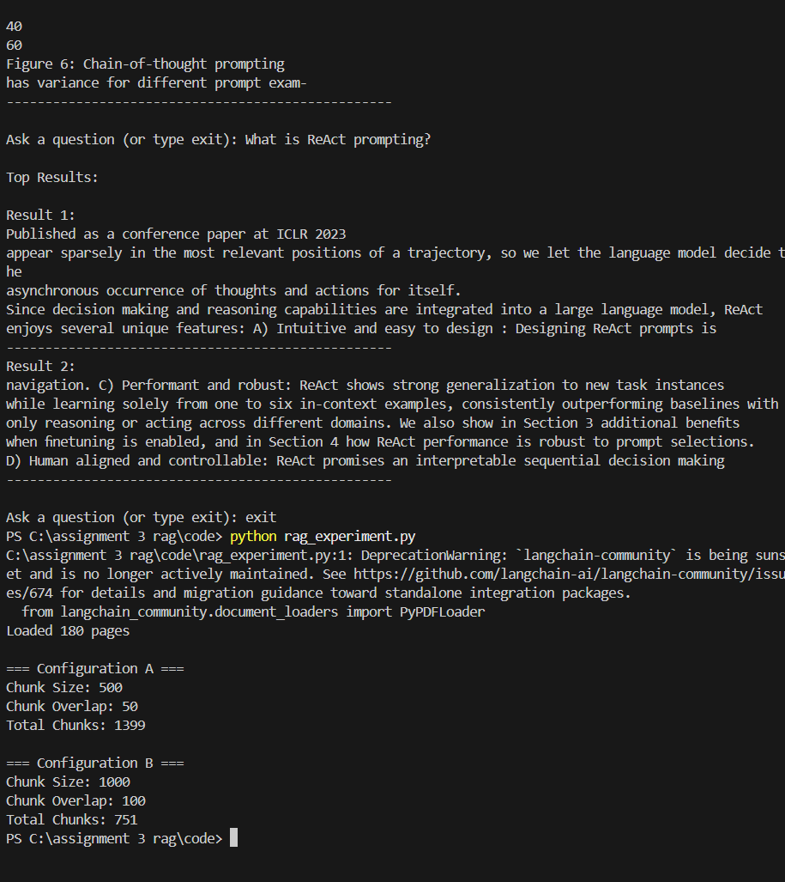

Document Loading and Chunk Creation
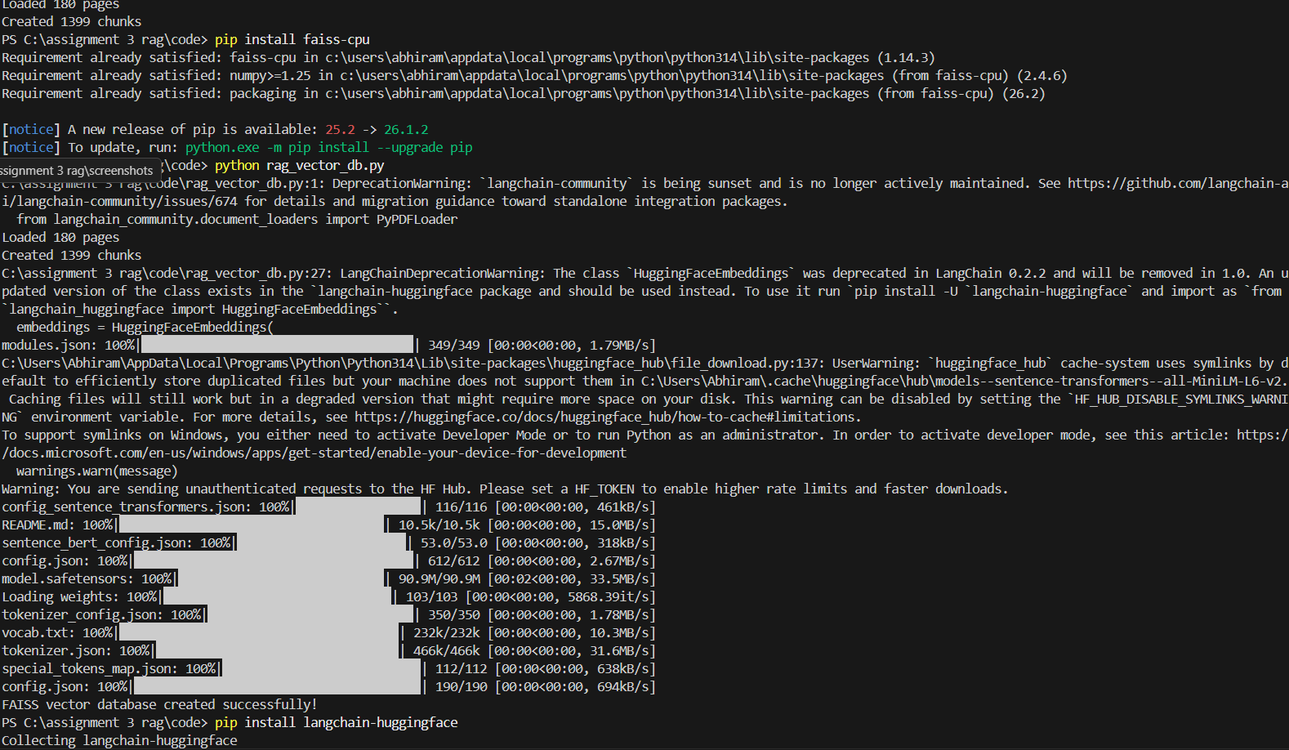

FAISS Vector Database Creation

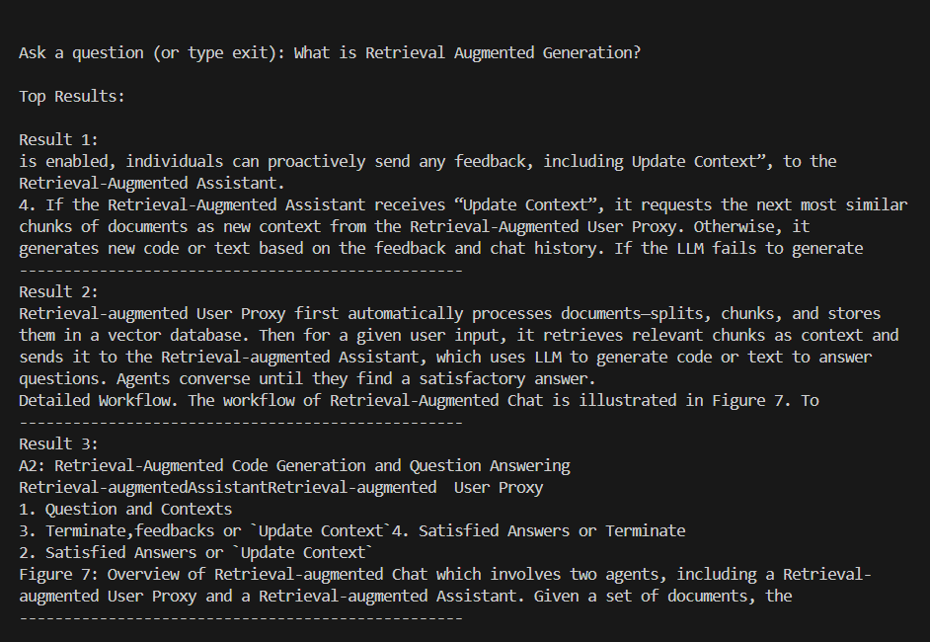

Retrieval-Augmented Generation Query

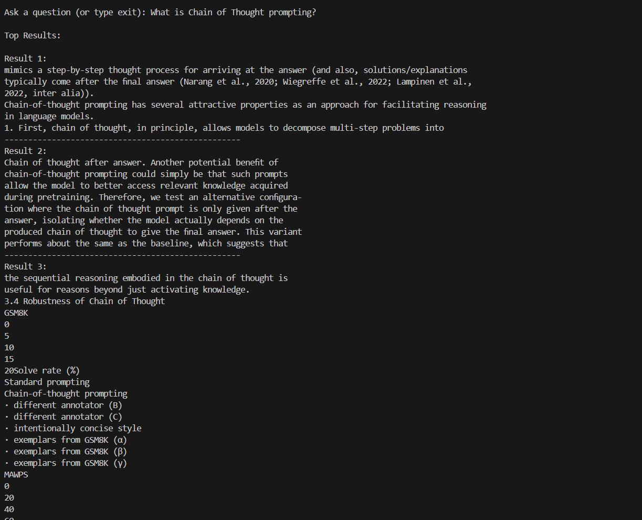

Chain-of-Thought Query

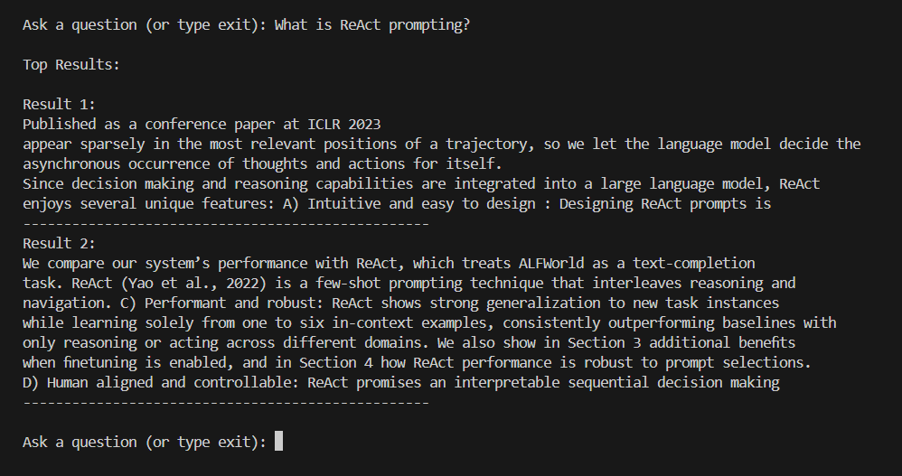

ReAct Query

Source Code Repository
The full implementation, including the Python source files, FAISS vector database creation, chatbot implementation, query expansion demonstration, and experimental evaluation, is available in the following GitHub repository:
Repository: https://github.com/abhiram-srh/assignment-3-rag

11. References
1. Lewis, P., Perez, E., Piktus, A., Petroni, F., Karpukhin, V., Goyal, N., Küttler, H., Lewis,
M., Yih, W. T., Rocktäschel, T., Riedel, S., & Kiela, D. (2020). Retrieval-Augmented
Generation for Knowledge-Intensive NLP Tasks. Advances in Neural Information Processing
Systems (NeurIPS 2020). arXiv:2005.11401.
2. Wei, J., Wang, X., Schuurmans, D., Bosma, M., Chi, E., Le, Q., & Zhou, D. (2022). Chain-
of-Thought Prompting Elicits Reasoning in Large Language Models. Advances in
Neural Information Processing Systems (NeurIPS 2022). arXiv:2201.11903.
3. Kojima, T., Gu, S. S., Reid, M., Matsuo, Y., & Iwasawa, Y. (2022). Large Language
Models are Zero-Shot Reasoners. Advances in Neural Information Processing Systems
(NeurIPS 2022). arXiv:2205.11916.
4. Yao, S., Zhao, J., Yu, D., Du, N., Shafran, I., Narasimhan, K., & Cao, Y. (2022). ReAct:
Synergizing Reasoning and Acting in Language Models. International Conference on
Learning Representations (ICLR 2023). arXiv:2210.03629.
5. Wu, Q., Bansal, G., Zhang, J., Wu, Y., Li, B., Zhu, E., Jiang, L., Zhang, X., Wang, C., &
Zhang, C. (2023). AutoGen: Enabling Next-Gen LLM Applications via Multi-Agent
Conversation. Microsoft Research. ArXiv:2308.08155.

